CS 1358 Introduction to Programming in Python

Fall Semester 2019

Prof. Pai H. Chou

Self-Check 4

Due Date: Sunday, October 6, 2019, 11:59pm

Answer the following questions to check your understanding of your material. Expect the same kind of questions to show up on your tests.

## 1. Definitions and Short Answers

1. Given the command shown on the lecture slide  
   $ uniq mary.txt  
   What is
   * the **prompt**?

* + the **program name**?

* + the **command-line argument**?

1. What does the uniq program do?

filters out repeated lines in a file

1. What does the cat program do?

concatenate and print files

1. What does the grep program do?

print matched lines in the input file(s)

1. Is it possible that uniq and cat produce the same output? How?

Yes，如果 input file 只有一個且裡面沒有重複的句子

1. Given the command shown on the lecture slide  
   $ grep class myfile.py  
   What is the purpose of
   * class

搜尋的目標字

* + myfile.py

在myfile.py裡搜尋

1. Given the command  
   $ cat *.py  
   What is the meaning of *.py?

所有是.py結尾的file

1. What does the following command do?  
   $ python3 prog.py

以python3 執行prog.py

1. What is a **shbang** in a Python program?

#! (tells the shell which interpreter to use)

Where is it placed inside a Python program?

第一行

1. What does the command do:  
   $ chmod +x prog.py

add the executable permission to prog

1. What is the value of
   * len([3, 7, 2, 0, 8])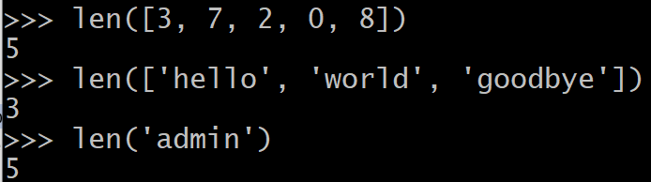

5

* + len(['hello', 'world', 'goodbye'])

3

* + len('admin')

5 #一個字元一個字元讀

1. Suppose you run the command  
   $ python3 showargs.py hello world goodbye  
   Inside the showargs.py program, suppose you have  
   import sys
   * What is the value of sys.argv?

[‘showargs.py’, ‘hello’, ‘world’, ’goodbye’]

* + What is the value of len(sys.argv)?

4

* + What is the value of sys.argv[1:]?

[‘hello’, ‘world’, ’goodbye’]

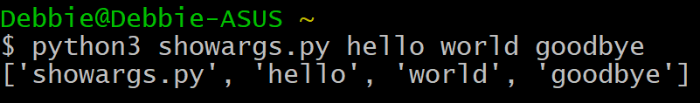

1. If the command $ python3 showargs.py hello world is used to run the Python program, what is printed by the statement  
   import sys  
   sys.stderr.write('cannot open input file %s\n' % sys.argv[1])  
   ?

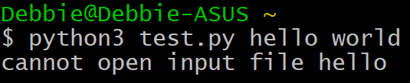

1. If the file mary.txt contains the following lines  
   Mary had a little lamb  
   little lamb, little lamb  
   Mary had a little lamb  
   its fleece was white as snow  
   what is the **value** of L after executing the following statements?  
   fh = open('mary.txt', 'r')  
   L = fh.readlines()  
   fh.close()  
   ?

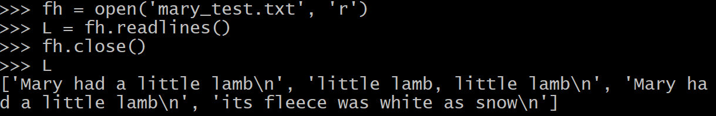

1. What is the purpose of end='' in the statement  
   print(line, end='')  
   ?

因為平常print會加一個new line

打這一行才不會多一個new line

1. Explain why  
   'hello'.find('e')  
   results in the integer value of 1,

有找到，而且是在[1]找到

while   
'hello'.find('a')  
results in -1.

沒有找到

1. Rewrite the **string literal** "hello, I'm John." using
   * single quotes

'hello, I\’m John.’

* + triple single quotes

‘’’hello, I’m John.’’’

* + triple double quotes

"""hello, I’m John."""

instead of double quotes.

1. Rewrite the string literal 'she says, "This is great!" and left' using
   * double quotes

“she says, \”This is great!\” and left”

* + triple single quotes

‘’’she says, “This is great!” and left'''

* + triple double quotes

""" she says, “This is great!” and left”””

instead of single quotes.

1. Rewrite the string literal '\\n means newline' using a **raw string**.

r’\n means newline’

1. After executing the statement  
   t = 'hello' "world"  
   What is the value of t?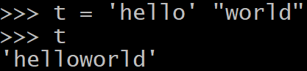

‘helloworld’

1. What is the value of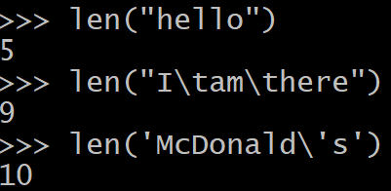
   * len("hello")

5

* + len("I\tam\there")

9

* + len('McDonald\'s')

10

1. Rewrite the following triple-quoted string literal using a non-triple-quoted string literal  
   sourceCode = '''<html>  
   <body>Welcome</body>  
   <html>'''
   * on one single line

sourceCode = ‘<html>\n<body>Welcome</body>\n<html>\n’

* + on three separate lines

sourceCode = ‘<html>\n’\

‘<body>Welcome</body>\n’\

‘<html>\n’

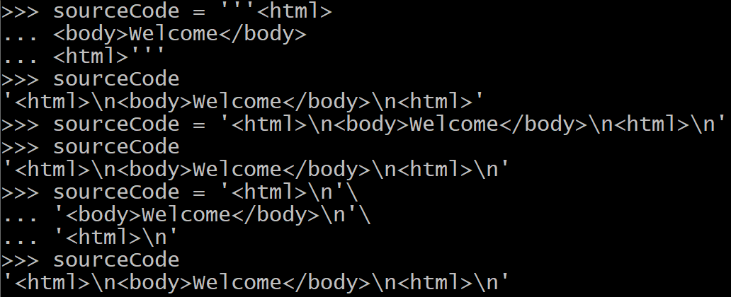

1. Assume   
   month = 7  
   day = 4  
   year = 2019  
   How do you format the date using % formatting so that it appears as strings (expressed as string literals)
   * '7/4/2019'

'%d/%d/%d' % (month,day,year)

* + '07/04/2019'

'%02d/%02d/%04d' % (month,day,year)

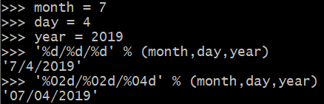

1. What is the value of
   * '%9.2f' % 13.5

' 13.50'

* + '%9.2f' % 123456789.0193

'123456789.02'

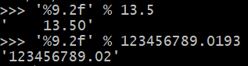

1. What is the meaning of 5e2? 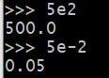

5.0 x 102 = 500.0

What is its data type?

floating point with 10-based exponent

1. What is the value of 5e-2?

5.0 x 10-2 = 0.05

1. What is the value of '%c' % 100, given that ord('a') has the value of 97?

'd'

1. What is the format string S such that S.format(month, day, year)  
   is equivalent to the traditional formatting of  
    '%d/%d/%d' % (month, day, year) ?

S = '{}/{}/{}'

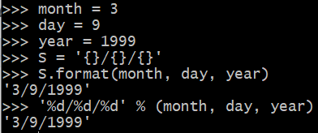

1. What is the value of the expression  
   'one {0}, two {0}s, three {0}s'.format('apple')?

'one apple, two apples, three apples'



1. What is the format string S such that   
   S.format(12)  
   evaluates to the string  
   '12 decimal is 0c hex and 14 octal'

S = '{0:02d} decimal is {0:02x} hex and {0:02o} octal'



1. What is the value of the expression  
   'lastname {1}, firstname {0}'.format('John', 'Smith')?

'lastname Smith, firstname John'



1. Rewrite the following expressions as **f-string**:
   * '%d/%d/%d' % (month, day, year)

f'{month}/{day}/{year}'

* + '{:02d}/{:02d}/{:04d}'.format(month, day, year)

f'{month:02d}/{day:02d}/{year:04d}'

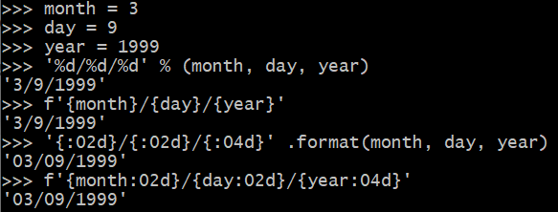

1. What is the value of the expression
   * 'www.nthu.edu.tw'.split('.')

['www', 'nthu', 'edu', 'tw']

* + 'Mary had a\nlittle lamb'.split()

['Mary', 'had', 'a', 'little', 'lamb']

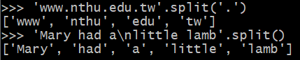

1. Suppose you type the unix command wc (lightblue) and get the output (lightgreen) as shown below:  
   $ wc mult.py  
    9 32 249 mult.py  
   What are the meanings of 9, 32, and 249?

9 lines, 32 words, 249 characters

1. What is the value of the expression
   * '(' + ')('.join(['a', 'b', 'c', 'd']) + ')'

'(a)(b)(c)(d)'

* + ''.join('Mary had a little lamb'.split())

'Maryhadalittlelamb'

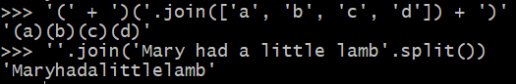

1. Assume you have   
   import string  
   What is the value of
   * string.punctuation
   * string.digits
   * string.ascii_lowercase
   * string.whitespace
   * string.printable

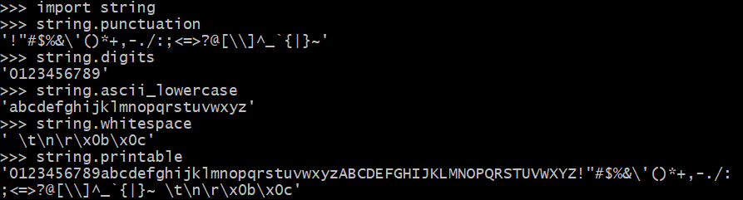

## 2. Programming Exercises

1. Write a program that prompts the user to input two strings and reports the two strings' lengths, by reporting the shorter string first. But if they are of the same length then keep them in the original order. For example, (blue text = typed input, green highlight = program printout)  
   $ python3 compstr.py  
   Enter a string: Great  
   Enter another string: job  
   Shorter string: job (length 3)  
   Longer string: Great (length 5)  
   $ python3 compstr.py  
   Enter a string: Mary  
   Enter another string: lamb  
   First string: Mary (length 4)  
   Second string: lamb (length 4)  
   $

Note that in case the strings are of different lengths, the program says Shorter and Longer, but in case the strings are of equal length, the program says First and Second. You don't actually print in color… the letters are colored for illustration purpose only.

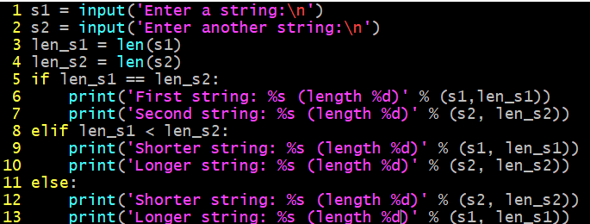

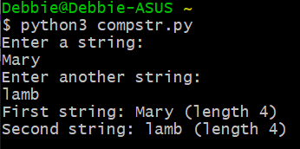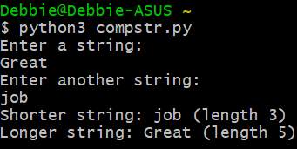

1. Write a Python program named catn.py by modifying the template code to implement the unix utility command cat with -n option, which adds the line number in front of every line of a file.
   1. First version: support the command with **optional** -n flag and **one file**. Note that the line number is formatted   
      $ python3 catn.py mary.txt  
      Mary had a little lamb  
      little lamb, little lamb  
      Mary had a little lamb  
      its fleece was white as snow  
      $ python3 catn.py -n mary.txt  
       1 Mary had a little lamb  
       2 little lamb, little lamb  
       3 Mary had a little lamb  
       4 its fleece was white as snow  
      $

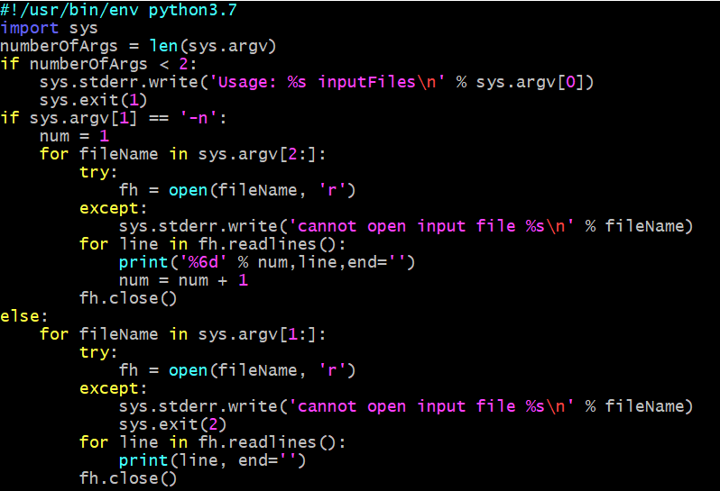

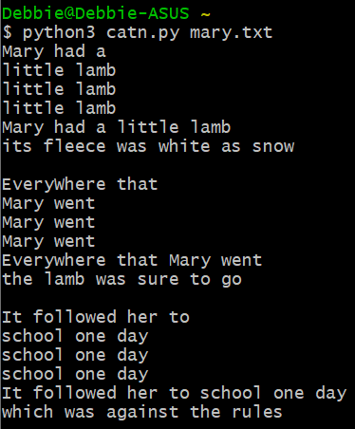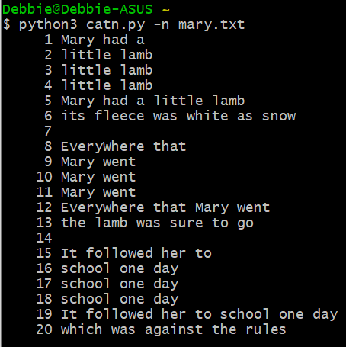

* 1. Second version: handles **one or more files** with optional -n flag. In case of multiple files, the line number restarts from 1.

